# Lab 13. Calling the SharePoint API from a flow

**Author:** Serge Luca aka “Doctor Flow”

**Updated by**: Dattatray-Patil

**Learning objective:** out of the box, Flow actions cover an essential part of the SharePoint API. However, some features are not covered, and you need to invoke the SharePoint API. That what the **Send an HTTP Request to SharePoint** action is all about.

**Duration:** 30 minutes

**Scenario:** in this example, we will create a Flow that will add a new currency field called “Price” to an existing SharePoint list. No existing out of the box action covers this.

## Tasks:

Perquisites :

Make sure you are familiar with the SharePoint REST API; if not, read this documentation <https://docs.microsoft.com/en-us/sharepoint/dev/sp-add-ins/working-with-lists-and-list-items-with-rest>, most specifically the section “The following example shows how to **create a custom field for a list”.**

Go to one of your SharePoint list settings:

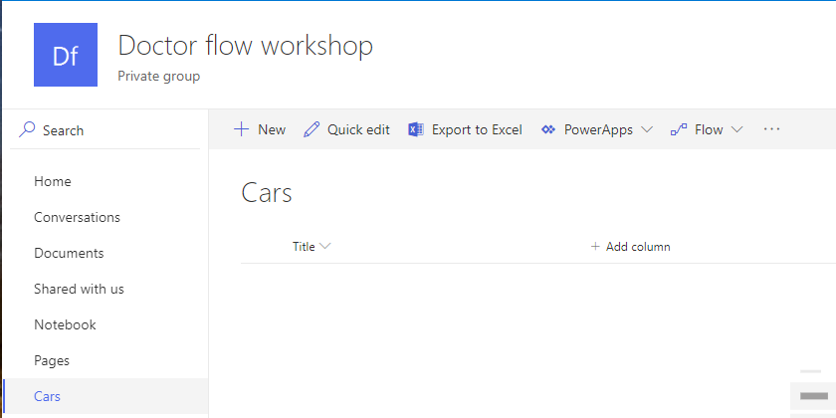

1. Create a new Flow from scratch. The Flow must start with a Button. Select **My flows > New flow > Instant cloud flow.**
2. Give a name to your flow. Select Manually trigger flow option
3. Click on “**New Step** and add a **Send an HTTP request to SharePoint** action defined like this (use your SharePoint URL and the list name that you copied to notepad):

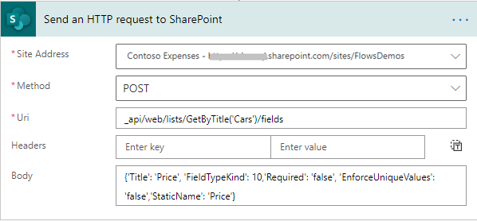

And in the body:

{'Title': 'Price', 'FieldTypeKind': 10,'Required': 'false', 'EnforceUniqueValues': 'false','StaticName': ''Price'}

Save and run your Flow. Typically, you will have a new column named “Price” in Cars list.

## We need your feedback

Do you want to report an issue or to suggest something? We need your feedback: <https://github.com/Power-Automate-in-a-day/Training-by-the-community/issues>